Task 1:
What is a Peocess?
In Java, a process represents an executing program or application, distinct from a thread. While a thread is a lightweight unit of execution within a process, a process itself is a self-contained execution environment managed by the operating system.
Task2:
What is a thread?
In Java, a thread represents a single, independent path of execution within a program. It is the smallest unit of execution that can be managed by a scheduler, typically part of the operating system.
Task 3:
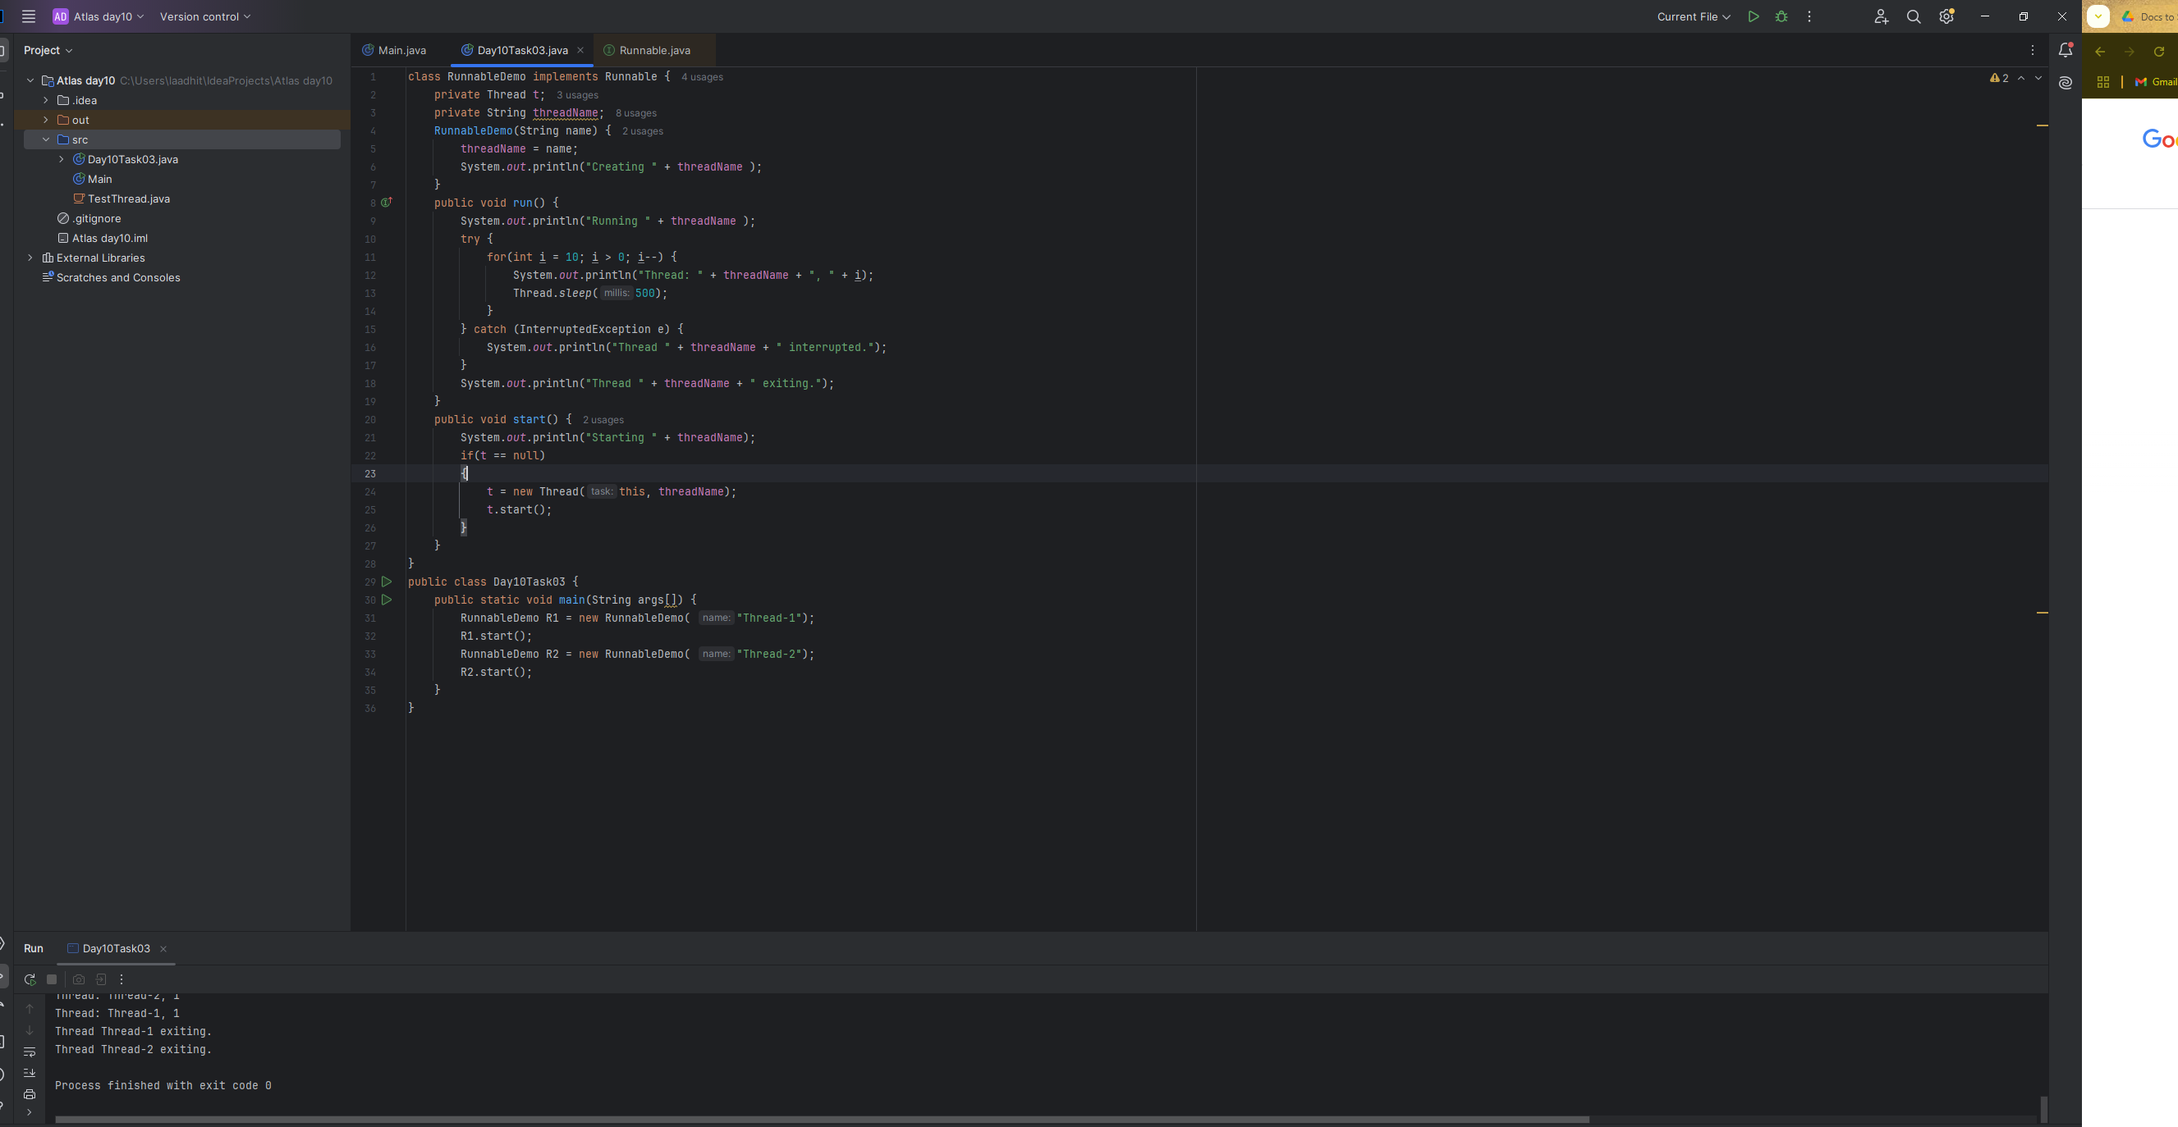
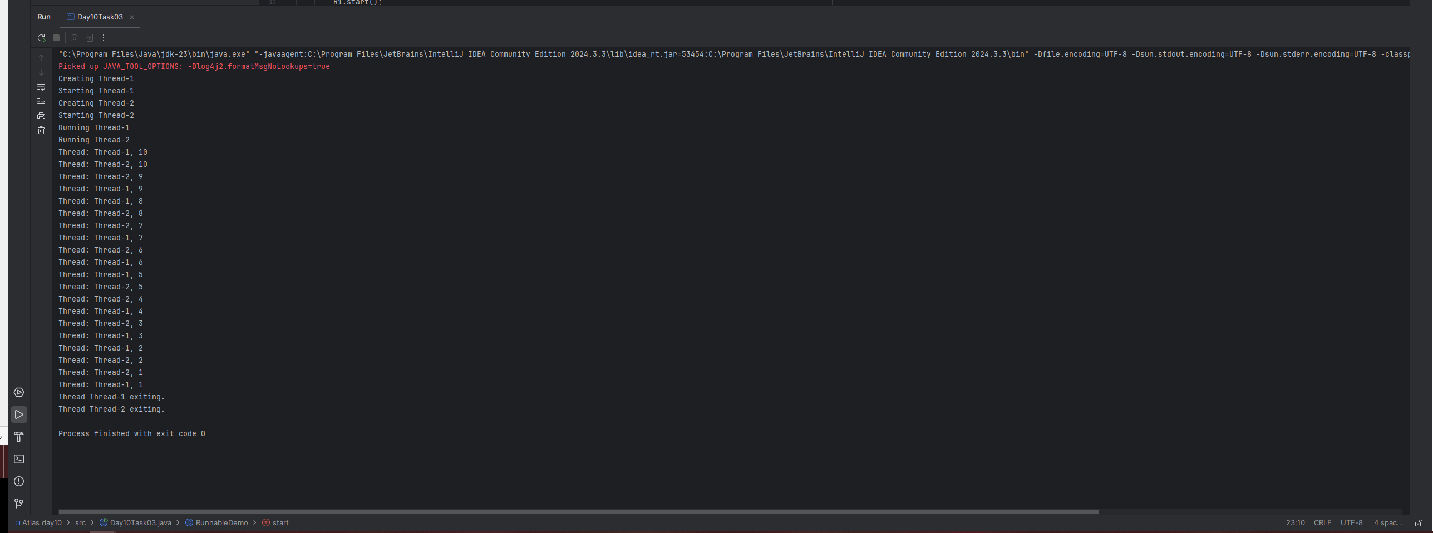

Task 4:
Extending the Thread class in Java is a way to create custom threads by inheriting the properties and functionalities of the Thread class. This allows you to define a new class that represents a thread of execution, and then start it using the start() method. The run() method within the extended class will contain the code that the thread will execute.
Task 5:
Java provides various methods within the java.lang.Thread class and related concurrency utilities to manage and control threads. Key methods include:
Thread Lifecycle and Control:
- start():
Initiates the execution of a new thread by calling its run() method in a separate thread of control.
- run():
Contains the code that constitutes the thread's execution logic. This method is typically overridden when extending Thread or implementing Runnable.
- sleep(long millis):
Causes the currently executing thread to pause for a specified number of milliseconds.
- join():
Causes the current thread to wait until the thread on which join() is called terminates. Overloaded versions allow specifying a timeout.
- yield():
A hint to the scheduler that the current thread is willing to yield its current use of a processor, allowing other threads to run.
- interrupt():
Interrupts this thread. This sets the thread's interrupted status to true.
- isInterrupted():
Tests whether the current thread has been interrupted.
- interrupted():
Tests whether the current thread has been interrupted and clears the interrupted status.
Task 05: class Counter {
private int count = 0;
public void increment() {
count++;
}
public int getCount() {
return count;
}
}
class ThreadDemo extends Thread {
Counter counter;
ThreadDemo(Counter counter) {
this.counter = counter;
}
public void run() {
for (int i = 0; i < 10; i++) {
counter.increment();
}
}
}
public class Day10Task05 {
public static void main(String[] args) {
Counter counter = new Counter();
ThreadDemo t1 = new ThreadDemo(counter);
ThreadDemo t2 = new ThreadDemo(counter);
t1.start();
t2.start();
try {
t1.join();
t2.join();
} catch (InterruptedException e) {
e.printStackTrace();
}
System.out.println("Final count: " + counter.getCount());
}
}
Task 06:
class Counter {
private int count = 0;
public synchronized void increment() {
count++;
}
public int getCount() {
return count;
}
}
class ThreadDemo extends Thread {
Counter counter;
ThreadDemo(Counter counter) {
this.counter = counter;
}
public void run() {
for (int i = 0; i < 10; i++) {
counter.increment();
}
}
}
public class Day10Task05 {
public static void main(String[] args) {
Counter counter = new Counter();
ThreadDemo t1 = new ThreadDemo(counter);
ThreadDemo t2 = new ThreadDemo(counter);
t1.start();
t2.start();
try {
t1.join();
t2.join();
} catch (InterruptedException e) {
e.printStackTrace();
}
System.out.println("Final count: " + counter.getCount());
}
}
Task07:
class Counter {
private int count = 0;
public void increment() {
synchronized (this) {
count++;
}
}
public int getCount() {
return count;
}
}
class ThreadDemo extends Thread {
Counter counter;
ThreadDemo(Counter counter) {
this.counter = counter;
}
public void run() {
for (int i = 0; i < 100; i++) {
counter.increment();
System.out.println(i);
}
}
}
public class Day10Task05 {
public static void main(String[] args) {
Counter counter = new Counter();
ThreadDemo t1 = new ThreadDemo(counter);
ThreadDemo t2 = new ThreadDemo(counter);
t1.start();
t2.start();
try {
t1.join();
t2.join();
} catch (InterruptedException e) {
e.printStackTrace();
}
System.out.println("Final count: " + counter.getCount());
}
}
Task08:
class Counter {
private static int count = 0;
public static synchronized void increment() {
count++;
}
public static int getCount() {
return count;
}
}
class ThreadDemo extends Thread {
Counter counter;
ThreadDemo(Counter counter) {
this.counter = counter;
}
public void run() {
for (int i = 0; i < 10; i++) {
counter.increment();
System.out.println(i);
}
}
}
public class Day10Task05 {
public static void main(String[] args) {
Counter counter = new Counter();
ThreadDemo t1 = new ThreadDemo(counter);
ThreadDemo t2 = new ThreadDemo(counter);
t1.start();
t2.start();
try {
t1.join();
t2.join();
} catch (InterruptedException e) {
e.printStackTrace();
}
System.out.println("Final count: " + counter.getCount());
}
}
Task09:
import java.util.concurrent.locks.Lock;
import java.util.concurrent.locks.ReentrantLock;
class Counter {
private int count = 0;
private final Lock lock = new ReentrantLock();
public void increment() {
lock.lock();
try {
count++;
} finally {
lock.unlock();
}
}
public int getCount() {
return count;
}
}
class ThreadDemo extends Thread {
Counter counter;
ThreadDemo(Counter counter) {
this.counter = counter;
}
public void run() {
for (int i = 0; i < 10; i++) {
counter.increment();
System.out.println(i);
}
}
}
public class Day10Task0506070809 {
public static void main(String[] args) {
Counter counter = new Counter();
ThreadDemo t1 = new ThreadDemo(counter);
ThreadDemo t2 = new ThreadDemo(counter);
t1.start();
t2.start();
try {
t1.join();
t2.join();
} catch (InterruptedException e) {
e.printStackTrace();
}
System.out.println("Final count: " + counter.getCount());
}
}
Task 14:
Daemon threads are background threads that provide supporting services to user threads within a program. Their primary characteristic is that they do not prevent the program from exiting. When all non-daemon (user) threads have completed their execution, the program or Java Virtual Machine (JVM) will terminate, even if daemon threads are still running.
Key characteristics and purpose:
- Background services:
Daemon threads are typically used for tasks that support the main application but are not critical to its core functionality. Examples include garbage collection, logging, monitoring, and other housekeeping duties.
- Automatic termination:
Unlike user threads, daemon threads are automatically terminated by the system when all user threads have finished. This means the program does not wait for daemon threads to complete their tasks before exiting.
- Low priority:
Daemon threads are often considered low-priority threads, as their primary role is to provide auxiliary services without interfering with the main operations.
- Creation:
In languages like Java, a thread can be explicitly set as a daemon thread using a method like setDaemon(true) before the thread is started.
Analogy:
Consider a main performance (user threads) and a stage crew (daemon threads). The performance is the main event, and when it finishes, the audience leaves and the show ends. The stage crew, while important for setting up and maintaining the performance, does not prevent the show from concluding. They pack up their equipment only after the main performance is over, or they are abruptly stopped if the venue needs to close immediately.
Task 15:
What are the debugging tools in Java.. list down a few..
1.browser stack
2.Eclipse
3. Java Discovery Protocol
4. Raygun
5. IntelliJ IDEA
6. NetBeans
7. Rookout
8. Nerd Vision
Task 16:
Try to understand the error Messages.. What are they and when to you?
Few are given below.
Error Messages in Java
Compile time and run time
Compile time : grammatical mistakes … ;, {} , missing the code
Run time error or exceptions
Stack overflow error
Array index out of bounds
IO exception
Nulpointer exception
Task 17:
Stack trace:
In Java, a stack trace is a report that provides information about the call stack at a specific point in the execution of a program. It is commonly generated when an unhandled exception occurs, but it can also be retrieved programmatically.

